Hands-on ways to discover and experience the fresh flavours of Trentino, Northern Italy
Harvesting, processing, and preserving: all with your own hands
THE BEST OF TRENTINO… MADE BY ME

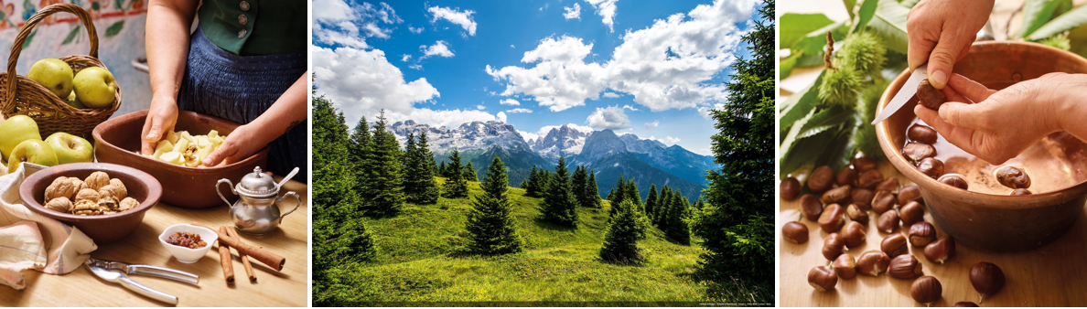
©Carlo Baroni
August 2019: New for autumn 2019, visitors to Trentino, Northern Italy can experience “Made By Me”, a new gastronomy project aimed at discovering and creating local produce through ten weekend experiences from September through to mid-November, across 16 agritourism businesses in Trentino. Visitors can take part in a series of sessions that guide them through harvesting and preserving practices, demonstrating how locally grown ingredients can be transformed into tasty delicacies. Visitors will hand-harvest ingredients from Trentino’s fields and farms to make delicious items from rose jam to sage and lemon syrup to aromatic herb-infused salts. These unique experiences help visitors to discover Trentino’s abundance of fresh growing produce and the region’s beautiful agricultural landscapes, all whilst providing them with mouth-watering souvenirs to take home.
Here are a sample of the experiences on offer:
Discover the secrets of sage and lemon syrup
From 7 – 8 September at the Maso Pertener Agritourism, visitors can learn how to make sage and lemon syrup in the foothills of the Brenta Dolomites, near Lake Garda. Certified for its organic products, the agritourism is located in Comano Terme in Val Lomasone, surrounded by meadows and woods. It’s the ideal place for a relaxing break, surrounded by nature.
Produce aromatic salt with mixed herbs
From 21 – 22 September, the Il Leprotto Bisestile Agritourism is offering guests the chance to learn about creating precious aromatic salt with mixed herbs. Set in Bosentino, with views over Lake Caldonazzo, on the Vigolana Plateau at an elevation of 700m, the agritourism grows medicinal, indigenous and aromatic herbs which are transformed into herbal teas, gourmet creams, aromatic salts and cosmetic products. Owner, Francesca Eccher, uses her background in heliciculture to breed snails for cosmetic use – the snail slime is a precious

ingredient in the anti-wrinkle face cream produced here!
Create sweet walnut honey to take home
From 9 – 10 November, guests can learn how to make sweet walnut honey by hand at the Maso Pra Cavai Agritourism. Situated in the heart of Bleggio Superiore close to Ponte Arche and the renowned Comano spas, this small family-run business is surrounded by greenery and woods. Run by the Brochetti family, this is where the precious Bleggio walnuts are cultivated. With an unmistakeable sweet and spicy flavour, visitors will learn how to create honey with Bleggio walnuts to take home.
The full list of farms and products that will be produced are listed below:
- September 7th and 8th
Agritur Maso Pertener - Sage and Lemon syrup
Agritur Maso Corradini - Raspberry jam
- September 14th and 15th
Agritur Dalaip del Pape - Vegetable stock
Agritur Maso al Sole - Fermented vegetables
- September 21st and 22nd
Agritur Maso San Bartolomeo + Coccole di Mammina - Apple jam
Agritur La Val + Leprotto Bisestile - Aromatic herb salt
- September 28th and 29th
Agritur El Mas - Sauerkraut
Agritur Maso Flonkeri - Rose petal jam
- October 5th and 6th
Agritur Malga Riondera - Spiced green tomato chutney
Agritur La Casa nel Bosco - Mix of officinal herbs and flowers for herbal teas
- October 12th and 13th
Agritur La Locanda dell'Arguta - Hardy kiwi jam
Agritur Fiores - Aromatic salt with organic herbs
- October 19th and 20th
Agritur Maso Kofler - Garden vegetable pesto
- October 26th and 27th
Agritur Solasna - Strudel jam
- November 9th and 10th
Agritur Berry House - Chestnut flour
Agritur Maso Pra Cavai - Honey with walnuts

For more information, visit: https://www.visittrentino.info/en/articles/food-and-wine/farmstays-preserves-and-jams

To learn more about Trentino, please see www.VisitTrentino.info

Images of Trentino can be downloaded here: https://gallery.visittrentino.info/en/

-Ends-

For further press information, please contact:
Daniela Resenterra, dresenterra@hillsbalfour.com / 020 7593 1771
Chloe Gorman, cgorman@hillsbalfour.com / 020 7593 1756

