**Happy Easter from Trentino… with a present!**

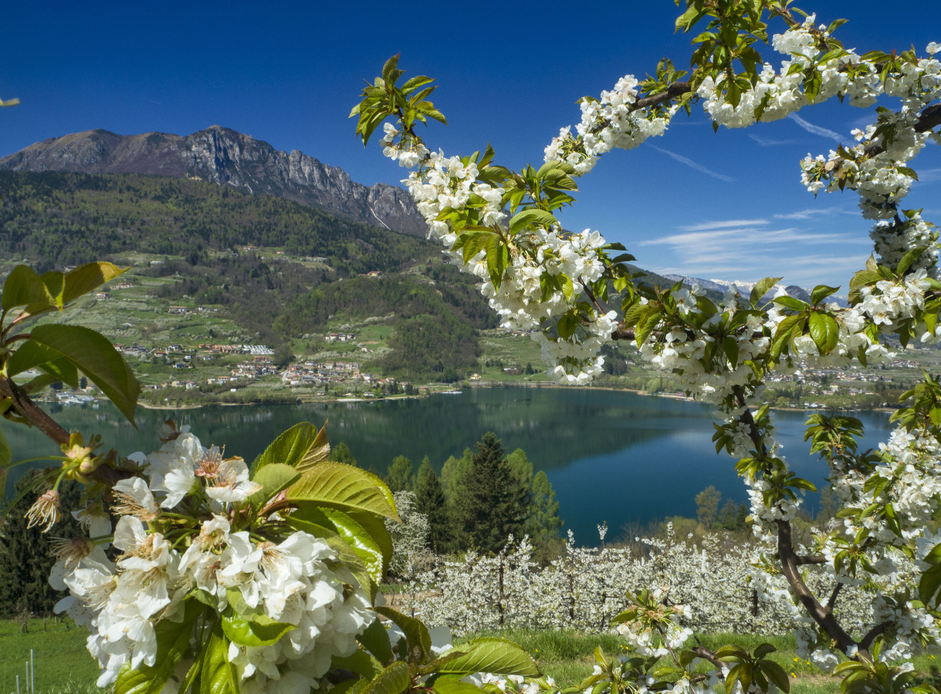

|  |
| --- |
| **London, United Kingdom, 30th March 2021 -** Spring is back again and we can’t wait to live it to the full soon enough. We long to be outside, smelling the blooming flowers, enjoying the colours of the Dolomites or having a picnic on the lake banks. Or simply breathing in the crispy air whilst visiting enchanted villages. Or just absorbing the silence of our forests.  For Easter, we are delighted to give you the opportunity to spend an hour surrounded by the nature of Trentino, offering you the chance to see the movie "With my own two hands" which premiered at the Trento Film Festival last year. You will learn a little more about our land, its changes and something of the people who live and work here.  Download the film “With my own two hands” here: <https://bit.ly/ConLeMieMani_TrentoFilmFestival> The following link will be available until Sunday, 18 April.  **About Trento Film Festival forthcoming online edition (30 April – 9 May**): <https://trentofestival.it/en>  Happy Easter from Trentino!  The Trentino PR team |

**For information on visiting Trentino go to** [**www.visittrentino.info/en**](http://www.visittrentino.info/en)